Abdullrahman Alghanim

05/02/2025

Module15_Lab 12

Capture the time service status in the terminal.

Capture the updated time service status in the terminal.

The terminal output showing a successful sealing key was created. DO NOT INCLUDE THE SECRET OR QR CODE!

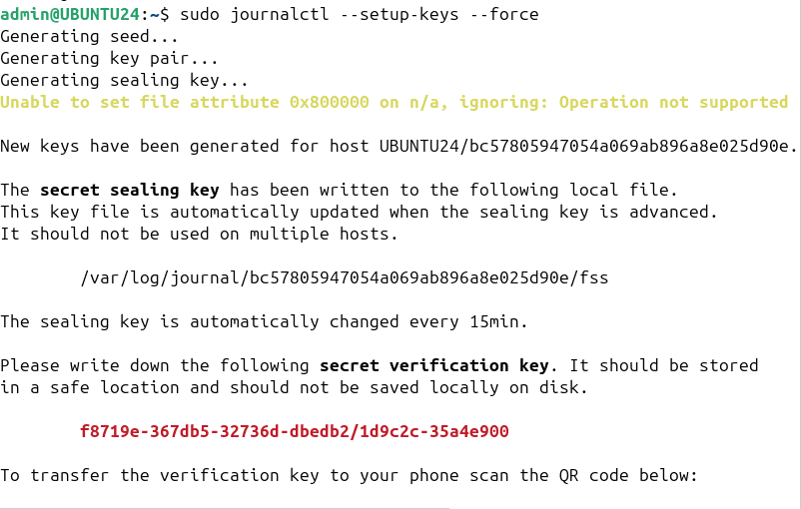

The completed and successful verification in the terminal

Terminal output showing successful rsyslog configuration

Terminal output showing successful cert creation

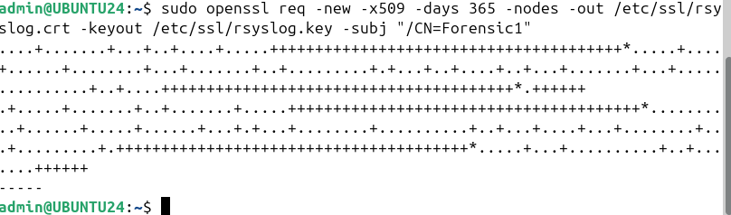

Terminal output showing a successful logging event and forwarding to the  
collector.

Terminal output showing a successful integrity check using AIDE

